JAVA String Concept

# String Introduction

* String is non premitive data types because it references a memory location where the data is stored in the heap memory or String Constant pool
* It references to a memory whether an object is actually placed
* So that the variable of a non primitive data type is also called the reference data types or object reference variable.
* All non primitive data types are simply called objects which are created by instantiating a class
* String ka size fixed nahi rahta
* String is the squence of the character or array of character

**char**[] ch={'j','a','v','a','t','p','o','i','n','t'};

String s=**new** String(ch);

* Java ke under charSequence name ka interface hota hai jiske vajah se hum char ko represent kar skte hai
* String name ki class java me pahle se hi bani hui hai and uske bahut sare methods pahle se defind hai

**Public final class string extends object**

**{**

**}**

**String class ka syntex hota hai and interview me puchha jata hai ki why string class is final**

* String class ka parent class object hai so voh object class ko inherit karti hai
* String class implements *Serializable*, *Comparable* and *CharSequence* [interfaces](https://www.javatpoint.com/interface-in-java)
* String ek class hone ke vajah se hum uska object bana skte hai

String c = new String();

Jaha c hume ek immutable object bana ke deta hai

* So string is the immutable object
* String create karne ke liye java me 3 classes hai 1) String 2) StringBuffer 3) StringBuilder

# Creating String in Java

* There are two ways to create a string in Java:
* Using String Literal -> String str1 = "Python";
* Using new Keyword-> String str1 = new String ("Java");

# Memory Area in Java

Java ke under 5 type ka areas bane hue hai

1) Method Area

2) Heap Area

3) Stack Area

4) PC Register

5) Native Method Area

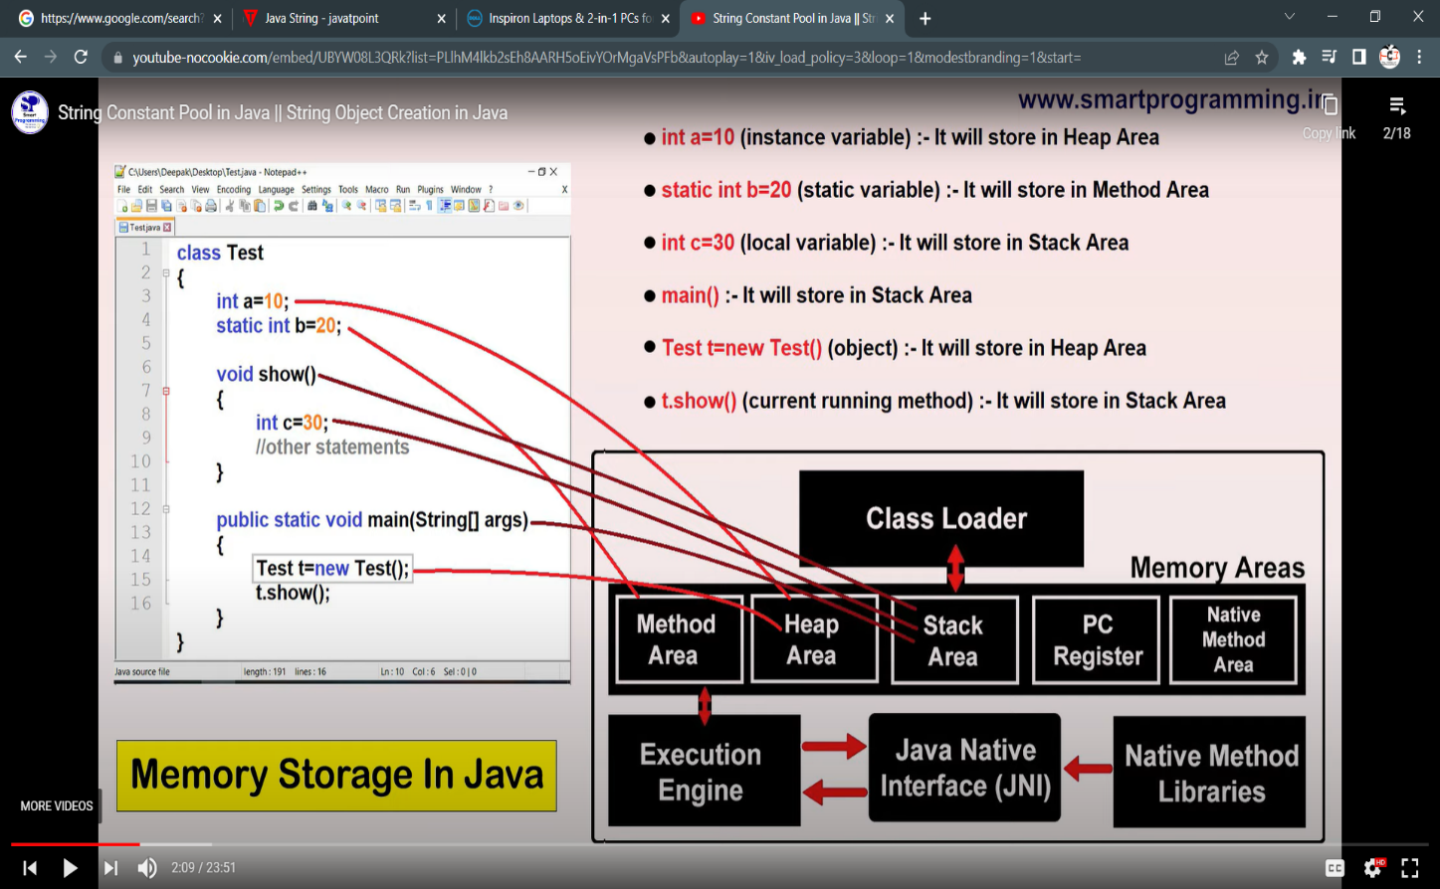

# String Constant Pool

* A “string constant pool” is a separate place in the heap memory where the values of all the strings which are defined in the program are stored.
* 1.6 version tak “scp” method Area me tha but after 1.6 version “scp” ko “heap Area” me transfer kar diya because method area ke ander size fixed rahta hai but heap area me jaise hi scp aaya to voh apne size ko dynamically increase or decrease kar skta hai

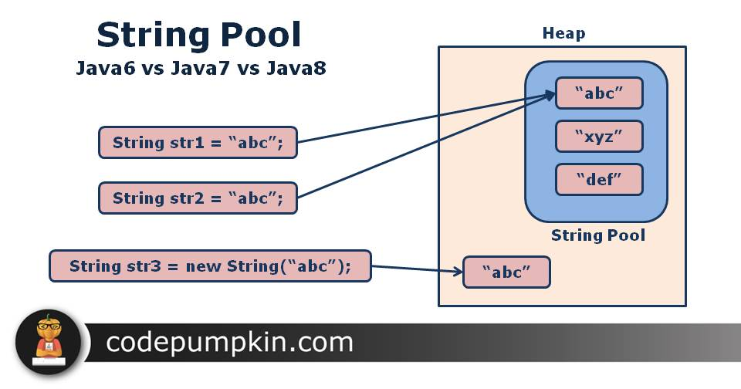

* String a = new String(“Rishikesh”);

Aisa likhne se Rishikesh name ka object heap and String pool dono me create ho jayega

* But String b =”Ram”; likhne se voh sirf String pool me hi create hoga

**Note : new keyword ka use karne par 2 time object create hota hai isliye hum string ko new keyword ki help se jada create nahi karte hai because voh jada memory ocupied karega**

* Heap area ke under Garbage collection ka concept lagta hai but SCP me Garbage collection ka concept nahi lagta because ek baar SCP me object create hota hai to usse hum delete nahi kar skte hai because of “ reference variable” ko internally JVM maintain karta hai

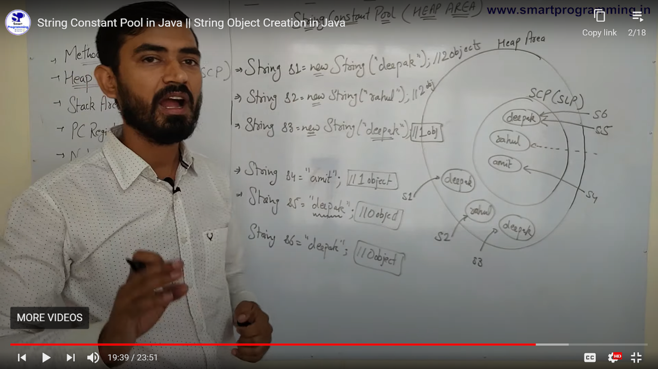

# String Object Are Immutable

* String is immutable which means it cannot be changed. Whenever we change any string, a new instance is created. For mutable strings, you can use StringBuffer and StringBuilder classes.

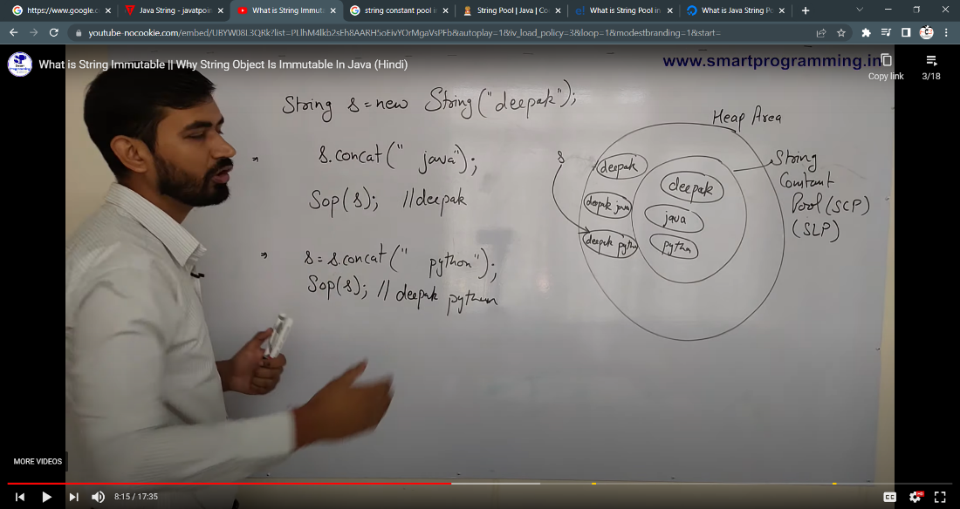

# String Constant Pool ke benefit

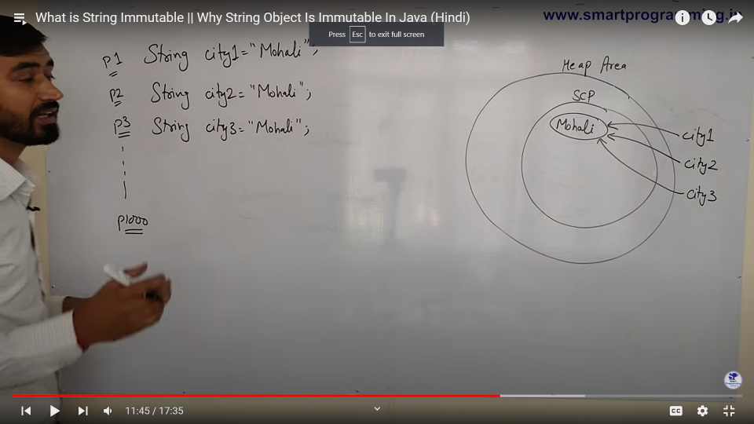

* Yaha par agar 1000 of people mohali me sahte hai to 1000 time mohali SCP me store nahi hoga sirf 1 time store arega and 1000 object usse refere karege jisse humhara project fast run karega
* Agar person 3 apna city change karke mohali se dehli change karta hai to scp me delhi name ka object create ho jayega and city3 object ab delhi ko point out karega

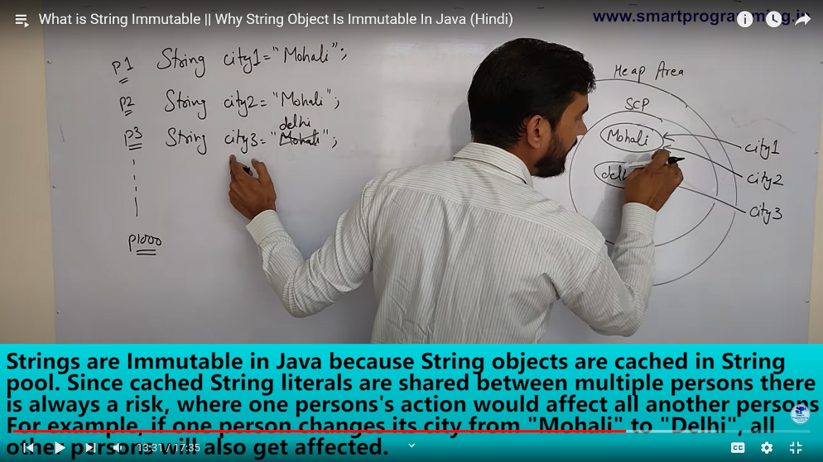

* SCP me create hue object future me use kiye jate hai isliye voh immutable hote hai
* String immutable ka meaning hai ki hum usski value ko change nahi kar skte balki voh ek new object create kar dega

# Why String class is final

* Final ek key word hota hai
* Jo class method or variable ke sath use hota hai
* Agar meri class final hoga to uss class ko koi bhi extends nahi kar skta

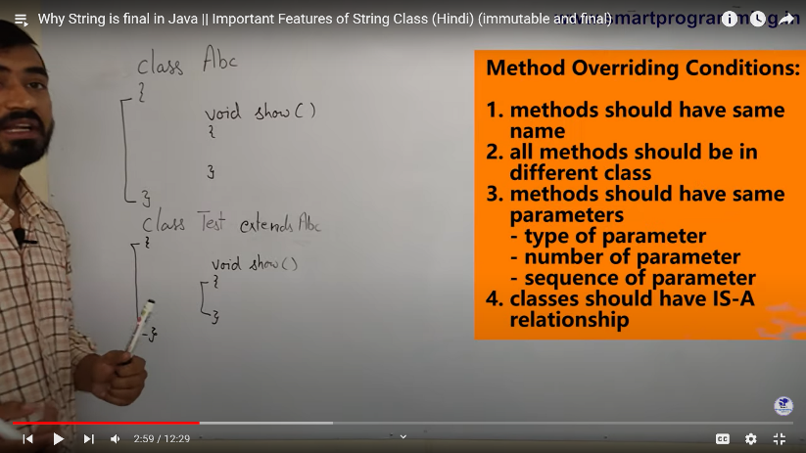

* Agar parent class ke method ko final bana diya to koi bhi child class method overide nahi kar skta
* Final a =5; likhne se a variable ki value fix ho jati hai and ab koi a ki value ko change nahi kar skta
* Isliye hum java me string class final hota hai jisse koi bhi developer string class ko inherite karke usske value ko change kar ske

# Importance of Steing class

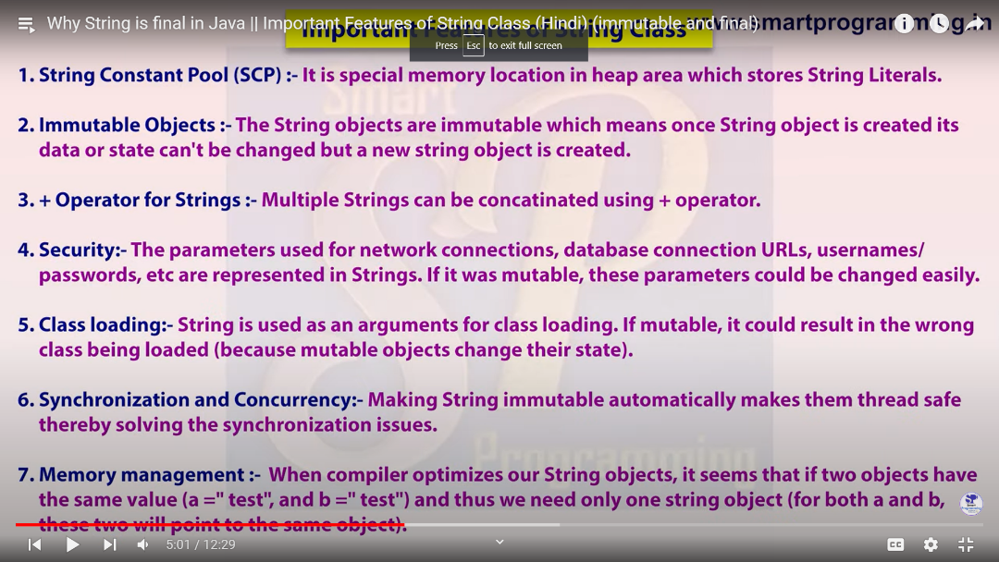

# String methods

* == operator : iska use reference comparision or address compariation ke liye use kiya jata hai

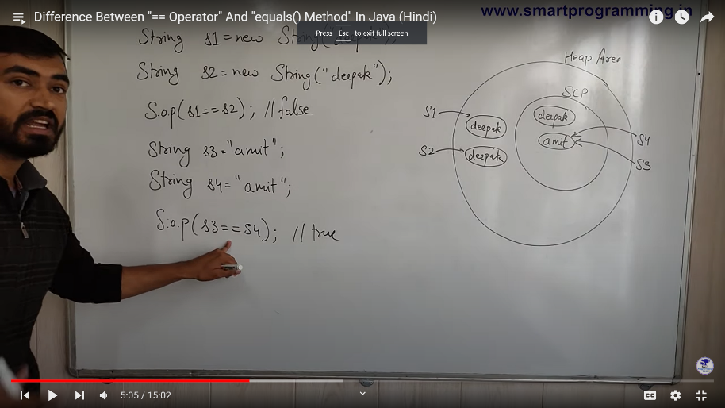

* .equals : yeh actual me object class ka method hai n ki string class ka but string class ne usse overide kar liya hai and jiske vajah se voh sirf content comparision ke liye use kiya jata hai

Uper ke example me s1.equals(s2) ka ans true aayega bcoz dono me deepak name hi likha hua hai

-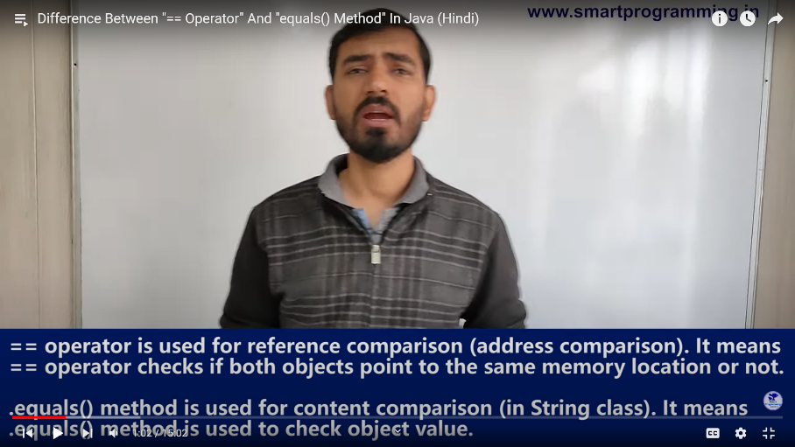

# String constuctors

* Impotance 6 constructor lists

1)public String()

2) public String (String s)

3) public String (StringBuffer sb)

4) public String(StringBuilder sf)

5) public String (char [] ch)

6) public String(byte []b)

* String sd = new String(); -> yaha ek empty string create ho gya hai
* String sa = new String(“rishikesh”); -> yaha sa yah rishikesh object ko refere karega
* StringBuilder sd = new StringBuilder(“Shivani”);

String ss = new String(sd);

Yaha humne ek mutable object ko immutable object me create kiya

* StringBuffer sd = new StringBuffer (“Shivu ”);

String ss = new String(sd);

Yaha humne ek mutable object ko immutable object me create kiya

* Byte [] b ={101,102,103};

String s2 = new String(b);

Sop(s2); --🡪 output efg

Yaha string ne 101 ki value ko e , 102 ki value ko f and 103 ki value ko g print karvaya hai

# Password ko hum char [] me store kiya karte hai n ki string me

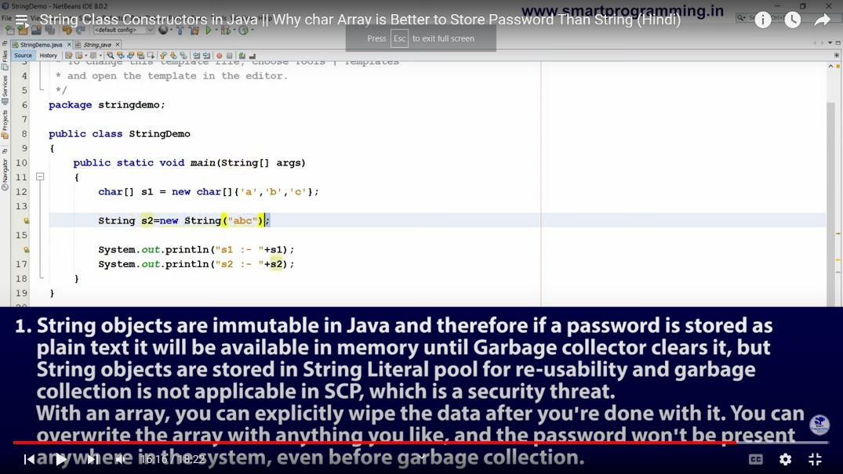

* Ek baar program ko run karke dekhna to idea aa jayega ki humm password ko string me kyu nahi likhte hai ex me password = abc hai

# String methods

* .length(); yeh integer me output deta hai

But example String name ==null;

And name.length(); -> output null point exception aayega

* isEmpty(); yeh ek boolen value dega
* .trim(); yeh hume string me value deta hai